**NUTRITION AND SCIENCES**

**The levels of pyramid**

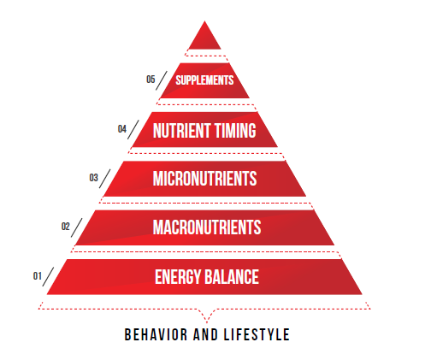

**Mindset and Material**

Accuracy, consistency, flexibility:

Do not be overly accurate, calculating every small bite/drops of grains of rice manipulates the human brain which effects the consistency (next topic) while losing flexibility, sanity tending to make your diet very difficult to follow.

Do not be overly detailed with numbers

All the three factors are directly proportional to each other. Be accurate depending on your goals and time limit which will let you be consistent and be more flexible with your diet.

To define accuracy, for example, if a person has to lose 100 lbs with unlimited time can be less accurate than a bodybuilder who is prepping for a competition in a month trying to shred more with limited time!